EXPERIMENT 7(B) :

Aim :

To demonstrate gradient descent using python.

Program :

import numpy as np

import matplotlib.pyplot as plt

np.random.seed(42)

X=2*np.random.rand(100,1)

y=4+3*X+np.random.randn(100,1)

x_b=np.c_[np.ones((100,1)),X]

learning_rate=0.01

n_iterations=1000

theta=np.random.randn(2,1)

for iteration in range(n_iterations):

gradients=2/100*x_b.T.dot(x_b.dot(theta)-y)

theta=theta-learning_rate*gradients

print(theta)

plt.scatter(X,y,label='Data')

plt.plot(X,x_b.dot(theta),color='pink',label='Linear Regression')

plt.xlabel('X')

plt.ylabel('Y')

plt.legend()

plt.show()

Output :

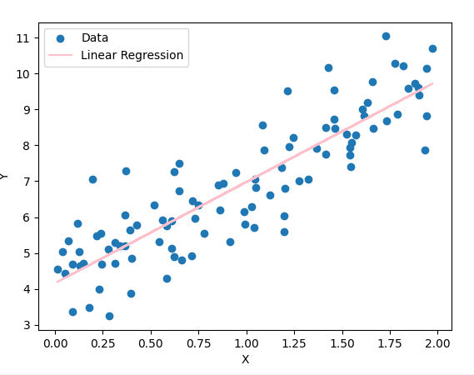

[[4.15809376]

[2.8204434 ]]